EXPT NO:5 | DASHBOARD DESIGNING
DATE: 24.01.2026 | DASHBOARD DESIGNING

PRE-LAB QUESTIONS

- How do dashboards support strategic decision-making?

Dashboards present key performance indicators (KPIs) and trends in a consolidated visual format, enabling decision-makers to quickly evaluate organizational performance, identify risks and opportunities, and take informed strategic actions based on real-time data.

- What role do dashboards play in AI monitoring systems?

Dashboards help monitor AI systems by visualizing model performance metrics, prediction outcomes, error rates, and anomalies. They enable continuous tracking of system behaviour and support timely intervention when performance degrades.

- Why is interactivity essential in modern dashboards?

Interactivity allows users to filter data, drill down into details, and explore different perspectives dynamically. This helps users gain deeper insights without cluttering the dashboard with excessive information.

- What cognitive overload issues exist in dashboards?

Cognitive overload occurs when dashboards present too many visuals, metrics, or complex designs at once. This can confuse users, slow decision-making, and reduce the effectiveness of the dashboard.

- How are KPIs derived from raw data?

KPIs are derived by cleaning, aggregating, and transforming raw data into meaningful indicators that align with organizational goals. These metrics summarize performance in a way that supports monitoring and decision-making.

IN-LAB EXERCISE:

OBJECTIVE:

To design an interactive analytical dashboard for monitoring key metrics.

SCENARIO:

An AI-based smart campus system requires a dashboard to monitor attendance, academic performance, and resource utilization in real time.

IN-LAB TASKS (Using PowerBI)
• Design KPI cards for attendance and performance
• Implement filters by department and semester
• Link multiple views for drill-down analysis

Output:

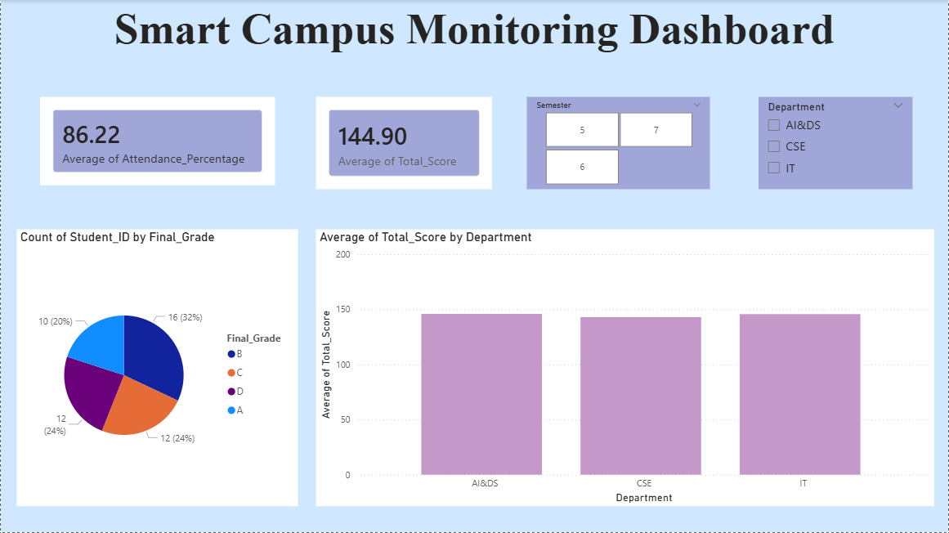

POST-LAB QUESTIONS

- How does interactivity improve analytical depth?

Interactivity enables users to dynamically filter data, drill down into specific categories, and explore relationships between variables. This allows deeper analysis beyond static views, helping users uncover hidden patterns, trends, and exceptions relevant to decision-making.

- Which KPIs are critical for academic monitoring?

Critical KPIs include attendance percentage, average academic performance scores, grade distribution, pass and fail rates, and department-wise performance. These indicators help institutions track student engagement, learning outcomes, and overall academic effectiveness.

- What design principles prevent information overload?

Information overload is prevented by using minimal and relevant visuals, maintaining a clear visual hierarchy, applying consistent colour schemes, limiting the number of KPIs displayed, and grouping related information logically for easy interpretation.
- How can dashboards be integrated with AI alerts?

Dashboards can be integrated with AI models that continuously analyse data and trigger alerts when predefined thresholds are crossed, such as low attendance or declining performance. These alerts enable timely interventions and proactive decision-making.

- How do dashboards enhance transparency in institutions?

Dashboards provide clear and real-time visibility into institutional performance metrics, ensuring stakeholders have access to accurate information. This promotes accountability, builds trust, and supports informed academic and administrative decisions.

LEARNING OUTCOME: Students understand dashboard design for AI-driven environments.

ASSESSMENT
Description | Max Marks | Marks Awarded
Pre Lab Exercise | 5
In Lab Exercise | 10
Post Lab Exercise | 5
Viva | 10
Total | 30
Faculty Signature

